These steps are followed by HR Systems when updating Holiday Schemes to record closure dates.
As at Mar 2022 TAG have confirmed that there is no portal equivalent for this process and no future migration date.

Contents

1. Introduction to Holiday Schemes 1
2. Updating a Holiday Scheme 1
3. Amending the Floating days in the Balance(s) 2
4. Extending the Balance Periods 3
5. Extend the Balance Calendar 4

Introduction to Holiday Schemes
Closure dates listed against a Holiday scheme will automatically be recorded as absences against all employee appointments linked to the scheme.
Holiday schemes are linked to employee appointments via the Balance assignment. Multiple Balances may be linked to the same holiday scheme. For example; the UAS Academic-related (G6+) and UAS Support Staff (G1-5) balances are both connected to the UAS Holiday Scheme.
Once departments have communicated their closure days for the upcoming leave year, the dates can be added to the holiday scheme.

Updating a Holiday Scheme
CoreTime/CoreRoster>System Parameters>Holiday Schemes>Company Holiday Details

  - Search for the holiday scheme you are updating, using either the code(e.g. UAS) or the scheme name (e.g. University Administration Services)

  - The list of existing closure dates are recorded in reverse chronological order. To add new dates click on the green + in the menu

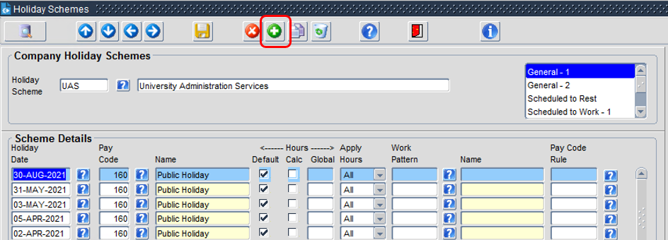

  - A blank row will be inserted

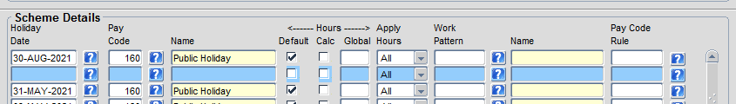

 | NB: The system will re-order the dates when you save the record.
  - In the ‘Scheme Details’ section, update the following fields:

Field Name | Description
Holiday Date | Click on the ‘?’ to select the first closure date you wish to add from a date picker, or type the date into the field
Pay Code | Click on the ‘?’ to select the appropriate pay code, or type the code into the field  - Code 160 = Public Holiday  - Code 3701 = Fixed Closure Day
Default | Tick

  - Repeat steps 4-6 until all of the closure dates have been added.

  - Save.

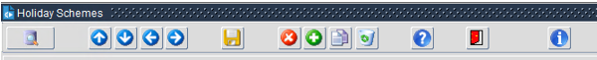

Amending the Floating days in the Balance(s)
CoreTime/CoreRoster>System Parameters>Balances>Entitlements Per Balance

The closure dates configured above form part of the employees' holiday entitlement. You may need to amend the number of floating days allocated by any associated Balances to ensure that the number of days available for the employee to book adhere to the following formula:

Floating days + Closure days* = University entitlement (38 days)

 | NB: If you have recorded a fixed closure day in the Holiday Scheme which is not to be deducted from the Balance, such as discretionary additional leave day awarded by the VC, do not include this in the calculation.

  - Search for the Balance you are updating, using either the code or the Balance name.

  - Remember there are usually at least 2 Balance versions for each Holiday Scheme, based on the different FTE Hours for G1-5 support staff and G6+ Academic-related, both of which need to be updated to reflect changes in the total number of fixed closure days.

  - In the ‘Balance Entitlements’ section find the row which relates the leave year you wish to update.

 | NB: the ‘Period’ field displays the year in which the leave year commences. E.g. for the 2020-21 leave year, you need to update the 2020 period. If the year you require does not appear in the list, or you are updating the last year year in the list, you will need to extend the Periods of the Balance Entitlement (See next section)

  - Calculate the number of floating days to apply using the formula shown above and update the ‘Days’ column.

  - Calculate the corresponding hours (using 7.5 hours for 37.5 FTE Balances and 7.3 for 36.5 FTE hour balances) E.g. 37.5 FTE Balance 24 days = 180 hours

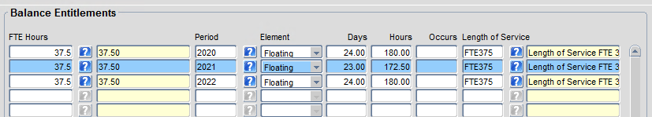

  - SAVE.

Extending the Balance Periods
If the Balance period you wish to update is not displayed in the ‘Balance Entitlements’ section, follow these steps. Employees can book annual leave for future leave years, so even if the closure dates have not yet been communicated, it is important to have at least one future period.

  - Click on the green + in the menu, an additional row will appear in the ‘Balance Entitlements’ section.

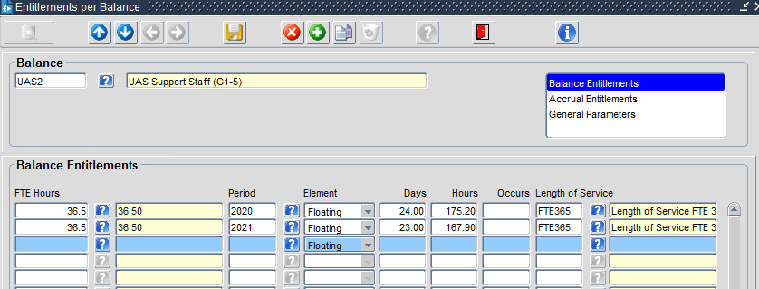

  - Update the new row with the following fields:
Field Name | Description
FTE Hours field | Enter to match the previous row(s)
Period field | Select the next period in the sequence in the LOV. If the period is not available, you will need to extend the Balance Calendar (see next section)
Element field | Leave as default ‘Floating’
Days | Enter the Days as per the calculation described in the previous section, or use a default value based on previous years if the closure dates are not yet available
Hours | Enter the hours as per the calculation described in the previous section, or use a default value based on previous years if the closure dates are not yet available
Length of Service | Select the relevant Length of Service scheme from the LOV based on the FTE hours. E.g. 36.5 hours – select FTE365 – Length of Service FTE

  - SAVE.

Extend the Balance Calendar
CoreTime/CoreRoster>System Parameters>Balances> Calendars

  - Enter/select the Balance you are updating

  - The default view should display Controls for ‘Carried Forward’.

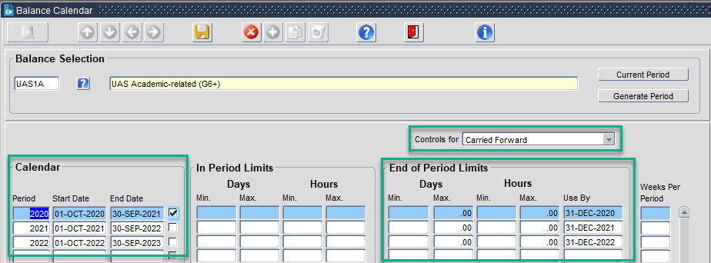

  - Update the ‘Calendar’ section as follows:

Field Name | Description
Period | Enter the value for the next annual leave period
Start Date | Start of next leave year
End date | Last day of next leave year

  - Update the ‘End of Period Limits’ section as follows:

Field Name | Description
Set the Days Max | .00
Set the Hours Max | .00
Use By date | 31st of December in the year the Balance period commences (this is the date by which leave carried forward from the following year must be used)

  - SAVE.

